

**Initial Learning Program – Software Engineer**

**Who We Are**

Tata Consultancy Services is a global IT services, engineering, consulting, and business solutions organization. We deliver real results to global business, ensuring a level of certainty no other firm can match. TCS offers a consulting-led, integrated portfolio of IT, Business Process Services (BPS), Infrastructure, Engineering and Assurance services. These services are delivered through our unique Global Network Delivery Model™, recognized as the benchmark of excellence in software development.

**Why Join TCS**

At TCS, you’ll have the opportunity to work for a well-regarded and thriving organization with $16.5 billion in global revenue. TCS ranked 58 in the top 500 US Brands survey by Brand Finance in 2016.

TCS has a 40+ year history in North America and has operated in Canada for 20+ years. We have more than 30,000 employees and operate 20 facilities in 15 states. We serve some 500 clients in 37 states including the District of Columbia and Puerto Rico. TCS continues to invest in new innovation centers across the country, and is the leading recruiter of IT services talent in the US.

**Commitment to Our People**

In 2016, The Top Employers Institute named TCS a Top Employer in North America, one of many recognitions we received for excellence in human resources management and community service.

As a global company at the forefront of a rapidly expanding field, we offer our associates the opportunity to work with many cutting-edge technologies, gain domestic and international experience, and explore multiple career tracks. We’ll help you map out a dynamic career path tailored to your personal goals. You’ll also find a supportive community of colleagues working together to positively impact our company, our clients, and our careers.

**Commitment to Our Communities**

* We are deeply invested in our Corporate Social Responsibility program in the US and Canada, which aims to address societal issues in the areas of health, education and environment.
* TCS is a national leader of Science, Technology, Engineering & Math (STEM) education programs, and is the founding partner of the national mentoring initiative Million Women Mentors.
* In fiscal year 2016, more than 15,000 TCS employees volunteered 42,000+ hours to support STEM education and other programs in their communities.
* We have provided computer science education to over 12,000 middle and high school students through goIT, a TCS flagship STEM ed program to inspire youth towards tech careers
* TCS has donated more than $25 million in philanthropic contributions to nonprofits in our local communities since 2012.
* TCS supports community wellness through our multiple marathon sponsorships, including the TCS NYC Marathon and the Boston and Chicago Marathons.

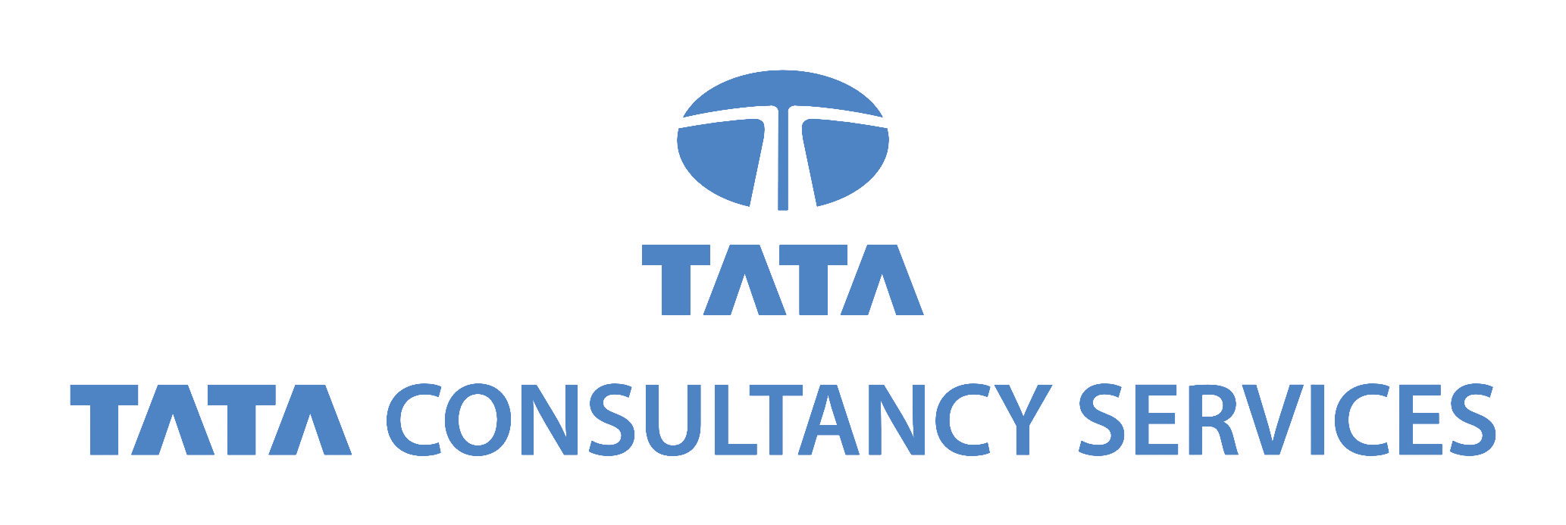

**Position Description:**

As a Software Engineer you will be trained to develop information systems by designing, developing, and installing software solutions to the world class clients we serve. Campus hires begin their careers with TCS in the Initial Learning Program. A fully paid training program designed to provide you with the information and training necessary to succeed at TCS and excel at client sites. However the learning does not stop there! TCS is committed to the continuous growth of its associates, in line with the core value of Learning & Sharing. We offer a Continuous Learning Program that spans technologies, domains, processes and soft skills. In addition, TCS associates are encouraged to undertake certifications and accreditations in a wide range of subject areas. With clients located across the US and globe, TCS can offer great flexibility in work location, excellent career advancement, and a variety of opportunities. TCS’ mentoring, career development, and on-the-job training ensure a smooth transition into your professional life and orient you to our culture, values, vision, and mission.

**Responsibilities:**

* Develop, create, and modify general computer application software or specialized programs
* Analyze user needs and develop software solutions
* Design or customize software for client use to optimize operational efficiency
* Improve existing systems by analyzing areas of modification
* Analyze and design databases with application areas
* Coordinate database development with a team or individually
* Maintain systems by monitoring, identifying, and correcting software defects
* Create technical specifications and test plans
* Update knowledge and skills regularly through in-house and external courses, manuals, and new applications

**Requirements:**

* B.S. in Computer Science (CS), Information Technology (IT), Information Systems (IS), Electrical Engineering (EE), Computer Engineering (CE), Informatics, or Software Engineering (SE)
* Cumulative or major GPA of 3.0 or higher
* Knowledge of basic computer science concepts, programming, and Information Systems
* Interest and willingness to travel and relocate
* Previous experience in Java/J2EE Development, C++/C#, .NET, VB/ASP
* Development and Database experience is preferred

**Qualifications:**

* Outstanding attention to detail and capacity to demonstrate continual learning
* Exceptional analytical and problem solving capabilities
* Excellent deductive and inductive reasoning skills
* Strong interpersonal verbal and written skills
* Ability to work both individually and with teams

TCS is an equal opportunity employer and an at-will employer. Nothing in this posting should be construed as an offer or a guarantee of employment